****SOURAV DAS** 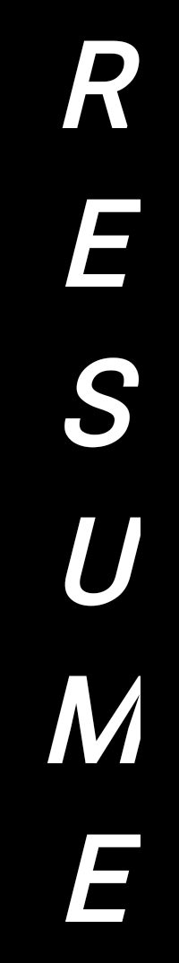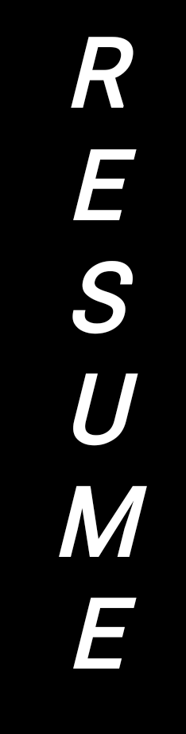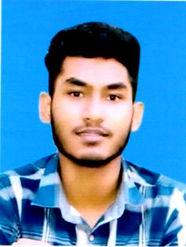

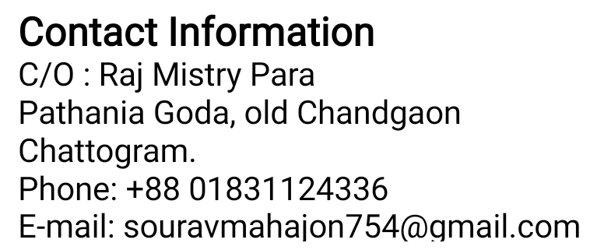



**Career Objective**

To pursue a career in a reputed organization that offers opportunity for-self- development as well as career development, to work under pressure in a professional and dynamic setting and to attain highest level of professionalism and efficiency to face the upcoming challenges of the current century.

**Academic Records**

* **Secondary School Certificate**
* Exam **:** S.S.C
* Board **:** Chittagong
* Institution **:** Koepara J.C.Sen High School, Raozan, Ctg.
* Group **:** Business Studies
* Passing Year **:** 2017
* Result **:** 3.82 (Out of 5.00)
* **Diploma In Engineering Certificate**
* Exam **:** Diploma in Engineering
* Board **:**  BTEB
* Institution **:**  National Institute of Technology (NIT)
* Group **:** Mechanical
* Passing Year **:** 2022
* Result **:** 3.60 out of 4.
* Course Name **: Computer Learning**
* Institution  **:** Chattogram Computer Academy
* Year : 2019
* Topic : Computer Basic
* Course Name : **English Spoken**
* Institution : Executive Care
* Year : 2020
* Course Name : **Industrial Training**
* Institution : TK Group
* Year : 18-12-2021 to 10-03-2022

**Career and Application Information**

* Looking For : Entry Level Job
* Available for : Full Time
* Preferred Job Category : Industrial

**Computer Literacy**

* Computer Operator
* M/S Word/Excel/Power point
* Typing Expert in Bangla & English
* Sales & Marketing
* Internet & E-mail



**Language Proficiency**

* English **:** Fair reading, writing and speaking ability
* Bengali **:** Mother Tongue



**Personal Details**

* Name : Sourav Das
* Permanent Address : C/O- Tapan Master Bari,

Vill: Quepara,, P.O: Quepara,

P.S: Raozan, Dist: Chattogram.

* Father’s Name **:** Dilip Das
* Mother’s Name : Nelu Das
* Date of Birth **:** 13th Decembor 1999
* Gender **:** Male
* Marital Status : Unmarried.
* Religion : Hindu
* Nationality : Bangladeshi (By Birth)
* Blood Group : B+ (Positive)
* NID No : 6904036115
* Mobile : +88 01831124336

**Declaration**

I undersigned, hereby declare that I will be responsible for any wrong information provided here.

Signature

Date:

***Sourav Das***